Background Checks through Clearstar:

Step 1:

Log into Clearstar. If you do not have login information, please contact: connect@clearstar.net

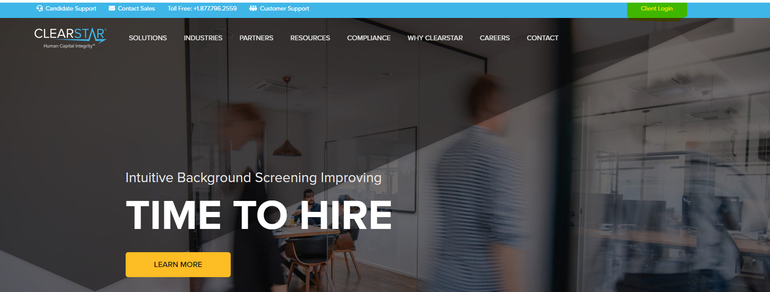

Step 2:

You will need to hover over create.

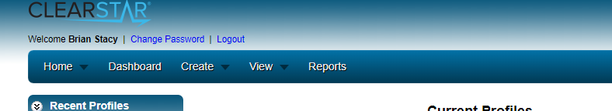

Step 3:

Under Create, click “An Applicant Request”.

Step 4:

Fill out the form and select which background check you would like Clearstar to perform. (They are labeled the same as NEOGOV.) \*\*\***ACCOUNTING CODE IS REQUIRED FOR BILLING.\*\*\***

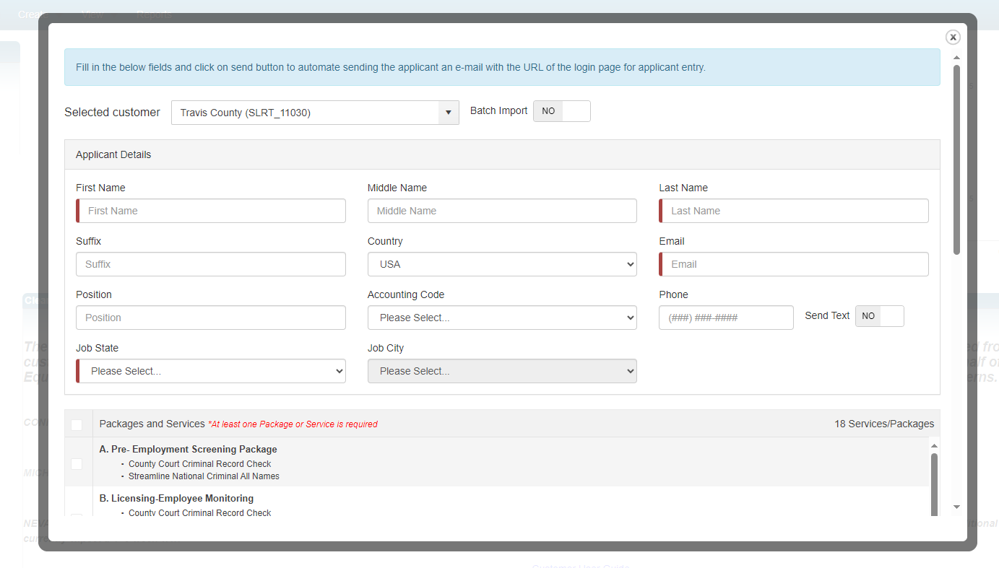

Step 5:

A background check authorization form has been sent to the candidate to fill out. Once the candidate fills out the authorization form, the background check will start.

Step 6:

Once completed, you will receive a notification stating the background check has been completed.

**Additional Information:**

If the candidate selects a non-electronic signature for authorization of background check, Clearstar will not perform the background until the authorization form has been uploaded. You will need to print the release form, have the candidate sign it, and upload it to the candidate’s profile.