Student Internship Request Process

The process for requesting a **STUDENT INTERN**:

1. **Define the Work Program-** Prior to requesting an intern, the hiring manager must define a work program and create a project description using the **Internship Request Form**. The form should specify criteria for successful candidates, including qualifications, the length and duration of the assignment. Each department/HR Liaison must ensure that both paid and unpaid internships are defined and approved before recruitment begins.
2. **Contact PBO-** Each department with requests for paid internships must contact PBO to confirm that funding is available.
3. **HRMD Review of Request-** HRMD will review the department’s approved request to ensure compliance policies with applicable labor laws. Following approval of the position request, HRMD will support the recruitment process by posting the position in NeoGov and actively engage local universities, colleges, and career fairs for student referrals
4. **Identify the Candidate(s)**- The hiring manager/mentor will interview applicants consistent with equal employment criteria to select an appropriate candidate(s) for the internship.
5. **Enter the Candidate(s) into Onboard in NEOGOV**
6. **Enter Candidate(s) into SAP-** Once approved by PBO and HRMD, the department is responsible for coordinating the creation of this position in SAP, specifying the appropriate student intern classification. (See page 4 for details)
7. **Onboarding-** HRMD will provide New Intern Orientation (NIO) sessions at the beginning of each semester. It is important that every intern (paid or unpaid) attend this session.

Concluding the semester:

**Invite Interns to Court**- As Internships near the end of the semester departments should coordinate with HRMD to invite Interns to Commissioners Court to meet members of the court and share their experiences.

**Request Intern Feedback**- At the conclusion of the semester, departments will receive a survey to forward to Interns to offer their feedback about the Internship experience.

**Remove Interns from SAP**- At the conclusion of the Internship, departments are responsible for removing Interns from SAP.

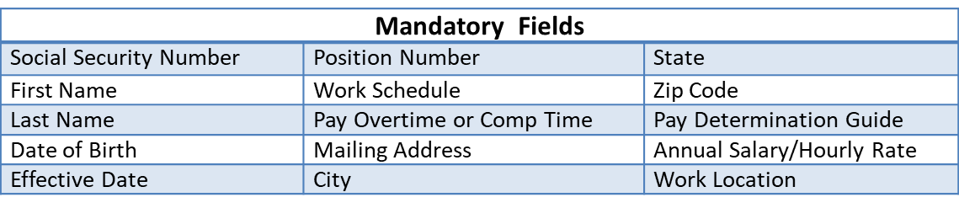

**Intern PAF Steps**

* 1. Find *Vacant* position **write down position number** or submit request to create new Intern position as though it’s a new regular position.

|  |  |  |
| --- | --- | --- |
| **Pay** | **Academic Status** | **Intern Classification** |
| Unpaid | Academic credit (Juv Probation) | Psych Intern (Juv Prob) |
| Unpaid | Academic credit  (HS, Undergrad, Grad) | Student Intern 1 |
| $12.00 | ACC Undergraduate | ACC Intern |
| $10.39 | High School | Student Intern 2 |
| $13.59 | Undergraduate | Student Intern 3 |
| $15.55 | Graduate | Student Intern 4 |
|  |  |  |

* 1. Gather information **before** beginning the new hire action in SAP.
  2. Complete Personnel Action Form (PAF) mandatory fields.
  3. Check form for errors/revise as necessary.
  4. Submit form for approval/track it.

**Intern PAF Steps**