**FY 2022 ITS Inventory Replacement Form - Instructions**

The FY 2022 ITS Inventory Replacement Form is fully integrated to SAP. This form contains data and automation to provide PBO, ITS and Departments/Offices the information they will need to create a budget request for FY 2022.

The intent of this form is to clarify to ITS and PBO the current systems in each department/office’s inventory of record from SAP.

***\*\*Please note that although all departmental inventory will be included in this form, not all inventory is qualified to be replaced through central computer budget as managed by ITS. Please use the guidelines outlined in the Budget Manual for eligible replacements. In addition you may contact your budget analyst for clarifications. \*\****

This information on the new form includes:

* What types of systems are in your inventory;
* Whether department purchased an item;
* Whether a grant funded the system; and
* What action is needed on those items.

Please note that no editing of the form is allowed. This is data comes directly from SAP. If it is incorrect, that means data in SAP needs to be fixed so that budgeting and replacement will be correct in the future. It is the responsibility of the departments/offices to review their request for accuracy. Please note any errors or omissions as soon as possible.

This form should be used as a tool by the departments/offices to facilitate budget conversations with ITS and PBO to ensure that your replacement schedule for FY 2022 meets your requirements, while meeting county budget and asset management requirements as well.

**Form Instructions**

1.) Type in your department number: 101, 114, 159, etc. to populate the inventory data:

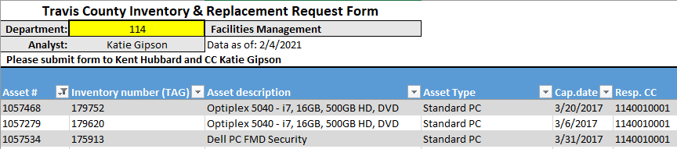

Using the FMD replacement list as an example, you see the SAP data this form provides. Eligible systems are identified within the target range of the FY – 10/1/2016 through 9/30/2017, and your PBO Budget Analyst is shown.

Note: The target range for FY 2021 may not be accurate as the capitalization date generated by SAP is simply the date that the assets were created from the received PO. Please note that there are systems on the outside of this date range that were shown with purpose. Review those systems that may have been overlooked or missed during the previous replacement year. If systems were recently replaced (for example if a machine was upgraded early for COVID-related work-from-home needs), they will be removed from the FY 2022 list.

Inclusion of Asset Type is a major change to the form data. This allows ITS to differentiate standard PCs from high-end PCs – which used to be just “PCM”. Also “LPT” which is now broken out into NB/m (Notebook mobile) and NB/w (workstation) in SAP.

2.) Next review the “Verify” column. For each system, please select a choice from the drop-down menu: Replace, Replace Dept Purchase, Upgrade, Downgrade or Retire.

* “Replace” means replace this system in the FY 2022 budget process through the central computer budget.
* “Replace Dept. Purchase” – per Budget Rules, department purchased systems are not automatically replaced with central budget funds – this MUST be authorized by PBO. Please add notes under Justification Required
* “Upgrade” means please allow additional budget for a higher grade system; standard PC to High-End PC; NB/m to a NB/workstation, etc. – This MUST be authorized by PBO. “New Asset Type for Upgrade” allows you to choose what you want to upgrade to. **The cost of the upgrade will also appear. Please add notes under Justification Required to state the business case for the upgrade as well as the funding strategy (internal funding or budget request) for the cost difference.**
* “Downgrade” means that you which to take a higher system and have it replaced with a standard desktop PC. No authorization is required for this action.
* “Retire” – if the department no longer needs the system, do not replace the system. If it has not been sent to the warehouse by the time ITS arrives to replace your systems, ITS can take this system from you, wipe the data and take it to the warehouse with your old replaced systems.
* “Discuss” If there are questions or more information needed on a particular device (such as verifying that a device was already replaced in FY 2020 or FY 2021 with Emergency Event funding) please check “Discuss” and enter any questions or notes on the right. ITS and/or PBO will follow up with you.

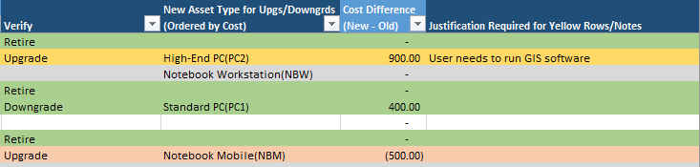

3.) On items that need further analysis by your PBO analyst, such as department-funded items, grant-funded items, or upgrades, please copy them when returning this form to ITS/Kent Hubbard to facilitate further conversations. Once the process decision is made, ITS will update the replacement schedule accordingly (budget request required, OK to fund, denied, etc).

When you are satisfied with your request, simply email the form to Kent Hubbard and copy Katie Gipson

Email: [Kent.Hubbard@traviscountytx.gov](mailto:Kent.Hubbard@traviscountytx.gov)

Phone: x41852

At any time, please do not hesitate to call/email Kent with any questions about the form or the replacement process itself. The more information ITS can provide on the front-end of the process, the better.